**IELTS overview**

The International English Language Testing System (IELTS) has been developed to assess the English language proficiency of people who want to study or work in English-speaking environments. Over 3,5 million tests were taken last year. More than 10 000 organisations in over 140 countries recognise and use IELTS for selection purposes.

There are two main tests: Academic and Genera l Training tests . As you are university students and IELTS serves to ensure your study success and mobility, our preparation course centers around exclusively IELTS Academic specialisation. The test questions are developed by item writers in Australia, Canada, New Zealand , the UK and the US.

The test consists of four separate sections, assessing four language skills – Listening, Read ing, Writing and Speaking. Each of the four sections is carefully designed to focus on one particular skill. The tasks and texts are accessible to all test takers, irrespective of their subject focus.

IELTS results are reported on a 9-band scale. IELTS test takers receive individual scores for each of the four test sections. The average of the four provides the overall band score.

At the beginning of the exam candidates are handed exam booklets and exam answer sheets (templates are in the Addendum 1). ! Candidates can make any notes they find useful in the exam booklets however it is crucial to transfer all answers in the Answer sheets before the exam ends. It is only Answer sheets that are being sent for marking so answers transferred partially inevitably result in losing marks! All IELTS candidates who sit the exam are rewarded with IELTS certificates of 2-year validity.

We have mentioned above four skills that are tested during IELTS examinations: two receptive skills -- Reading and Listening, and two productive skills -- Speaking and Writing. Today we are going to focus on Writing tasks.

In this section you are going to encounter two tasks for completion and one of them is the Writing task

In this task candidates are asked to describe, summarise or explain some visual information presented with a graph / table / chart / diagram in their own words. In a moment we will see examples of these tasks, but before let’s have a look at their key features outlined below**:**

**1.**In Task 1 you are allowed to write at least 150 words**(comment: *if the reply is shorter, candidate is penalized, 150-170 words is an optimal length though a lengthier answer is not penalized*)**

**2.**You are recommended to spend 20 minutes on this task **(comment: *you’d better comply with recommended time; longer task will inevitably take time from Task 2 which is twice as longer and weighs more in the overall Writing band score*)**

**3.** You don’t write anything before you have read the instructions and the question carefully

**(comment: you make sure you answer the question posed and never veer off-topic)**

**4.**All information you need for Writing task 1 is presented by the graph or table, nothing should be added from your own**(neither personal opinions or personal estimations)**

**5.**Even for such a short task, making a plan is essential **(comment: plan is sufficient, you don’t spend time on draft writing)**

**6.**In Task 1 you are adherent to a neutral, academic, formal style

**7.**You can write either by pen or pencil (**comment: *it makes no difference to the final score or marking process as long as your handwriting is easy to read***)

8.     Answer should be written on the Answer sheet

**Digging into Writing task 1. Line graph, bar chart, pie chart and a table**

Four key points underlined below remain on the board until the end of the lesson:

1. **you have to read the instructions and question carefully**
2. **all the information that you need is given in the diagram**
3. **you are expected to include the most important aspects of a given graph, table or chart in your text and add minor details logically**
4. **making a plan is essential**

Now we will  take a long hard look at these diagrams, at four of them: a line graph, bar chart, pie chart and table. For your convenience I will hand you pictures of them.

***The line graph below shows the main reasons people gave for moving away from a particular capital city to the countryside.***

***Summarise the information by selecting and reporting the main features and make comparisons where relevant.***

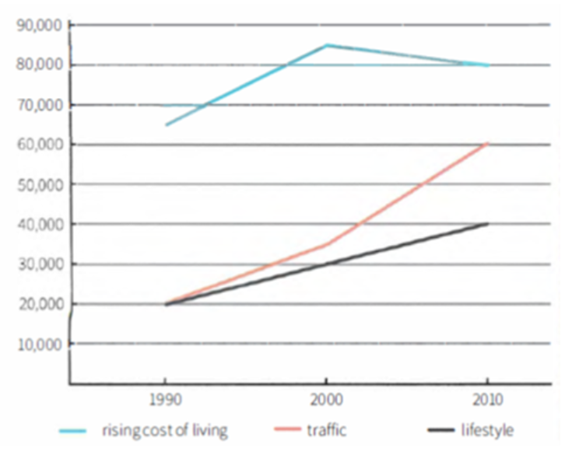

**The table below gives information about the underground railway systems in six cities. Summarise the information by selecting and reporting the main features, and make comparisons where relevant.**

**The graph below shows the percentage of urban/suburban and rural households in a European country that had Internet access between 1999 and 2004. Summarise the information by selecting and reporting the main features, and make comparisons where relevant.**

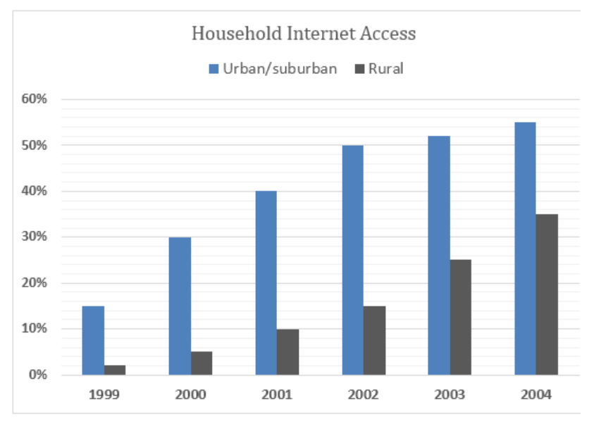

**The pie charts below show the average household expenditures in a country in 1950 and 2010. Summarise the information by selecting and reporting the main features, and make comparisons where relevant.**

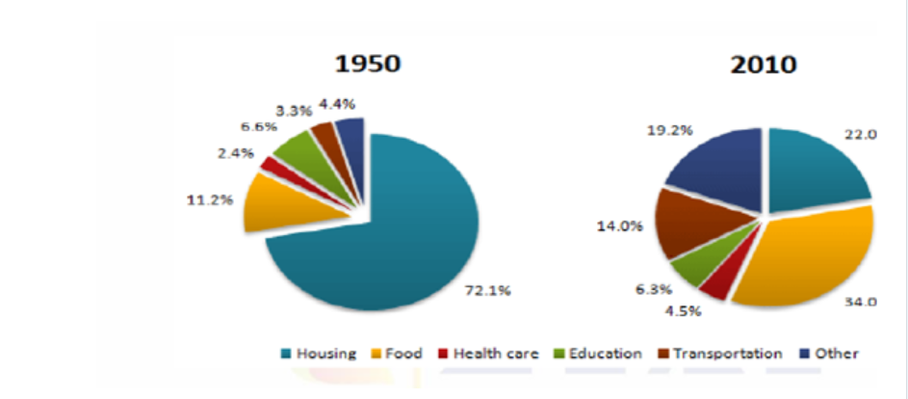

While looking at them we realize that we are dealing with a single source of information (mixed sources will be considered later during our prep course). What is more, there is a description explaining what this particular visual information is about and a question defining particular direction to focus on. Please find them and read aloud. By the by, have you noticed that the questions sound similar in all four examples? It is required to analyze data and express this in writing. While writing we take into consideration examiner’s expectations made up of 4 sections:

1. Task achievement
2. Coherence & cohesion
3. Lexical resource
4. Grammar

Task achievement means that a candidate is able to identify both **key and minor details of the graph, organize ideas in a clearly structured text**, accurately and coherently express them using appropriate vocabulary.  Though these four sections tend to be independent, all of them are closely intertwined which means poor performance in one of them lowers the grades in others. For instance, if there are coherence issues, it would leave Task achievement requirements unfulfilled.

Now we take a closer look at the very first Line graph explained in the following manner: ‘The line graph below shows the main reasons people gave for moving away from a particular capital city to the countryside’. Please try to express it in your own words. Any ideas?  We could say, ‘the line graph illustrates main reasons motivating people to leave a capital city for dwelling in the countryside’. What we have received is a **paraphrased task** – **a crucial step in describing any graph in the IELTS Writing Task 1 exam**.

We keep exploring the Line graph. It displays a 20-year period from 1990 to 2010, years are marked out on the horizontal x-axis. The vertical y-axis indicates the number of people leaving a capital city. Look and decide, what is the **key detail or ‘major/common trend’ as it is also called**? Any ideas? Yes, the major trend is that there is an overall increase in the number of people leaving throughout 20 years. The graph displays three main reasons that pressure people into moving. They are, as you can see: rising cost of living, traffic and lifestyle. Among the three causes, rising cost of living is an aspect contributing most of all to the relocation of the city population.  With these details revealed, we pass to the text structure.

**There is a fixed structure elaborated for the IELTS Writing task 1 whatever graph type is taken**:

§1. Introduction starting with the **paraphrased task (1 sentence)**

§2. Overall statement (1 sentence)

§3. Main body: first trend with comparison supported by the figures from the graph

§4. Main body: second trend with comparison supported by the figures from the graph

§5. Main body: third trend with comparison supported by the figures from the graph (*could be omitted if details are insufficient*)

**There is also an alternative structure where an Overall statement is put in the end**:

§1. Introduction starting with the **paraphrased task (1 sentence)**

§2. Main body: first trend with comparison supported by the figures from the graph

§3. Main body: second trend with comparison supported by the figures from the graph

§4. Main body: third trend with comparison supported by the figures from the graph (*could be omitted if details are insufficient*)

§5. Overall statement (1-3 sentences)

***You do not start writing anything before your answer has been carefully planned with a paraphrased task and overall statement composed, major and minor trends revealed and comparisons clarified.***

**Now look at the Line graph again and read the description on the board. It would not get a good score for Task Achievement. Guess why?**

The line graph illustrates the main reasons people gave for moving away from a capital city to the countryside.

The main reason was traffic. In 1990, 66,000 people left the city because of this, followed by 85,000 in 2000. 70,000 left in 2010, so it actually went down in those last ten years.

It was different for the other two reasons, which both started a lot lower than rising cost of living and both kept going up between 1990 and 2010. Subsequently, both categories saw large increases, with traffic first going up a lot between 1990 and 2000 and then even more clearly after that. Lifestyle went up to 30,000 initially, then up again until 2010.

***Group work***

1.       **First group**: in the table – paraphrase the task, identify major/minor trends/compose overall statement

2.       **Second group**: in the bar chart -- paraphrase the task, identify major/minor trends/compose overall statement

3.       **Third group**: in the pie chart -- paraphrase the task, identify major/minor trends/compose overall statement

**Table (Model answer)**

The table gives information on the underground railway systems in terms of the routes covered, passengers travelling annually and the year the railway system was initiated in six cities across the globe.

Overall, it is clear that two of the oldest systems are London and Paris but these are Paris and Tokyo that have a large number of passengers travelling annually. Meanwhile, London has the largest route travelled.

As per the table, the oldest underground railway service provider is in London, opened in 1863 and it also covers the longest rail route of 394 km. Paris comes at second place which was inaugurated in 1900. In terms of the size of the railway systems, London is nearly twice that of Paris but the congestion in terms of travelers is more at the later which falls at second place with 1191 million passengers yearly. Interestingly, Tokyo, which has only 155 kilometers of track, serves the greatest number of passengers per year, at 1927 million commuters.

These are then followed by the opening of the railway systems in Washington DC, Kyoto and Los Angeles. The latest built station is in Los Angeles which started to operate in 2001 and covers significantly smaller railway route than the others of mere 28 km. Kyoto, which was built two decades before the Los Angeles station has the smallest system comprising of only 11 kilometres. Kyoto and Los Angeles both serve the least number of passengers per year with 45 and 50 million respectively.

**Bar chart (Model answer)**

*The bar graph shows the percentages of city and rural households with the internet access in a European country from 1999 to 2004. Generally speaking, fewer percentages of rural households had the internet connection than that of city people and overall internet accessibility enhanced remarkably over the time.*

*In 1999, merely 2% of rural households in this European country had access to the internet while around 15% city dwellers had this facility. Next year, one out of every 20 rural houses gained this access while almost one-third of urban and suburban families were connected to the global internet. After two years, half of the city dwellers gained internet access while it was as small as 15% for rural citizens. Within the next two years, the percentages of households in rural areas who joined this network increased sharply, from 15% to 35%. The ratio of households in urban and suburban areas with internet access rose to roughly 55%, a slower extension than that of rural households during the last three years. The ratio of homes, both in cities and rural areas, with access to the internet was quite negligible in 1999 but improved dramatically within next 5 years.*

**Pie chart (Model answer)**

*The two pie charts depict the percentage of money spent on different goods and services of any nation in 1950 and 2010. Overall, it is clear that the spending pattern changed almost completely over the given time frame. Housing was the biggest investment sector in 1950, however people spent most of their money on food in 2010.*

*In 2010, the largest proportion of expenditure (34%) was on food whereas in 1950 this value was just 11.2%. There was a great difference in terms of the amount of money people spent on housing between the two years. In 1950, 72.1% of the total household budget went towards housing, compared to only 22% in 2010. It is interesting to note that funds allocated for education were roughly the same in the given years. Moreover, health care was the sector which got the least share over the period in question.*

*Analysing further, people had notably increased the amount of money spent on transportation between the two dates in which 14% of the total budget was disbursed in the later year comparing to only 3.3% in the former year. In addition, the charts show a significant rise in the proportion of money spent on health care in 2010 compared to 1950.*